Ubuntu inject SQL:

Log in Ubuntu;

Cd /var/www

Cd html

Ls

Nano all.php

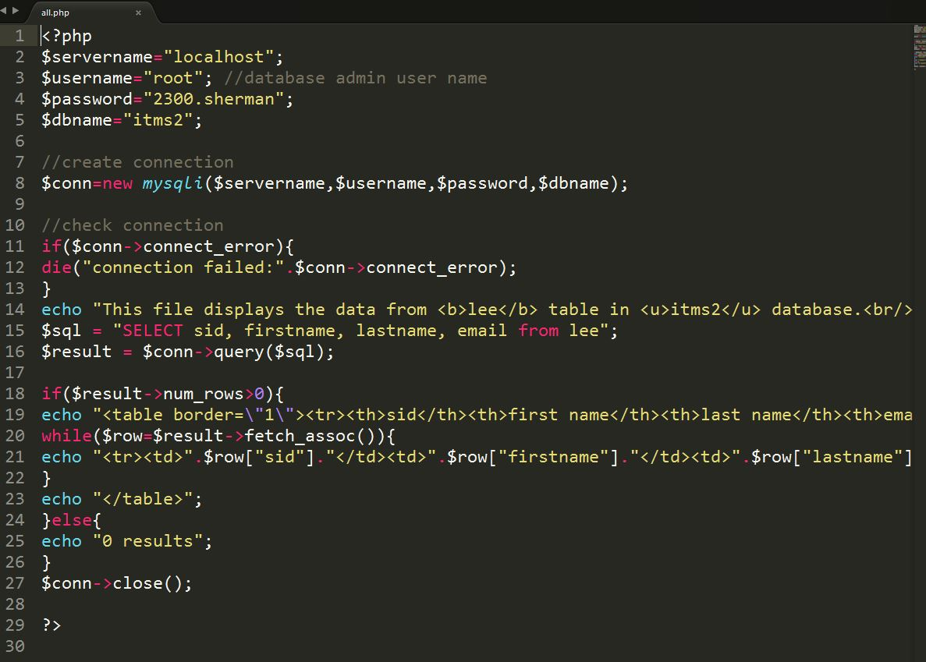

Nano fname.php

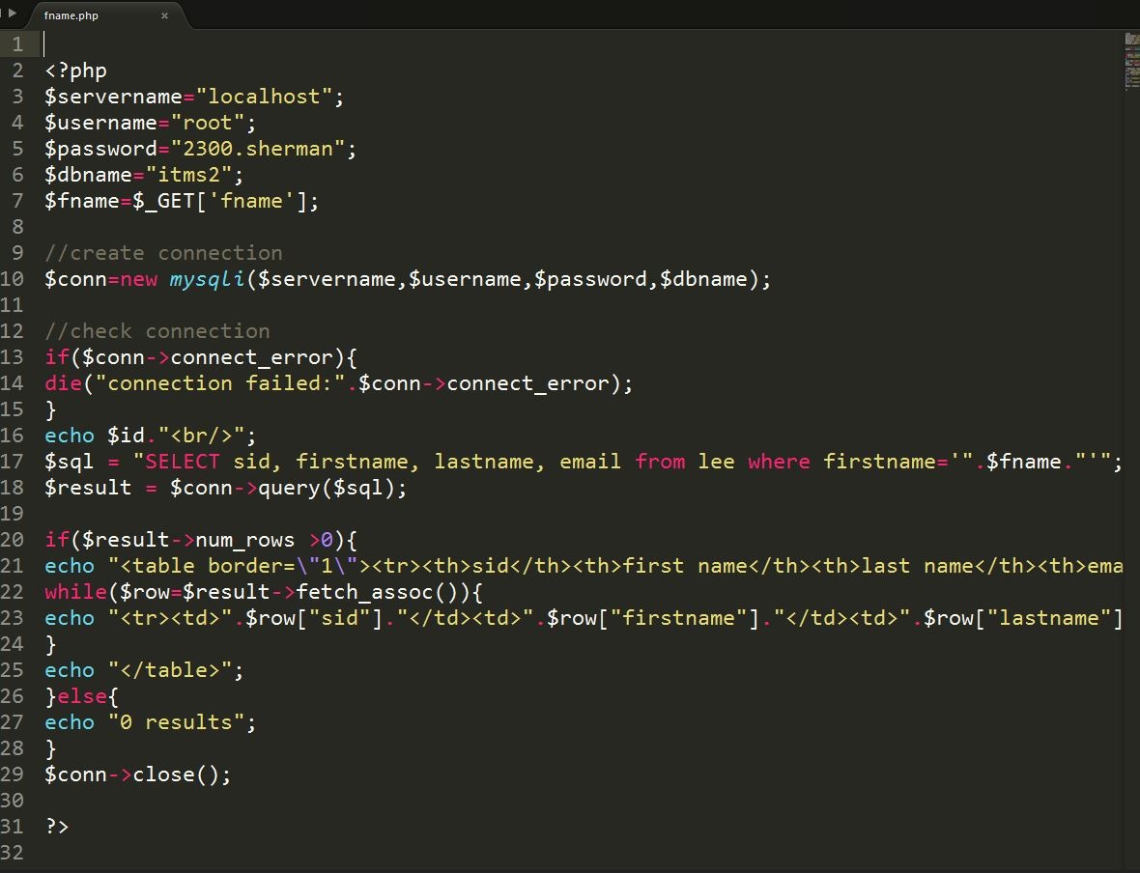

When run the query in web. type: localhost:8888/fname.php?name=hong ‘ or ‘1’ = ‘ 1